SAFEBOX DIGITAL LOCKER
@CREATIVITY THINK (9483175986/7019689991)

ABSTRACT:
Safebox Digital Locker is a web application designed to provide secure digital storage for individuals and organizations. Users can upload documents, manage access permissions, share files, and view dashboard reports. Administrators moderate uploads and shares, manage permission rules, and monitor analytics dashboards. The system is built with Django and Django Rest Framework for backend operations and React with Redux and Dropzone for frontend management. Safebox Digital Locker ensures encrypted document storage, controlled access, and comprehensive analytics for secure and efficient management of confidential files..

INTRODUCTION OF THE PROJECT:
With the growing need for secure document storage and controlled sharing, Safebox Digital Locker offers a centralized platform for individuals and organizations. Users can register, upload confidential files, manage permissions, share documents with authorized recipients, and monitor usage via dashboards. Administrators oversee document moderation, permission rules, and analytics dashboards. The backend leverages Django and Django Rest Framework for security, storage, and logic, while React, Redux, and Dropzone provide intuitive frontend interfaces. This system ensures secure, efficient, and trackable management of digital files for personal and organizational use..

PROJECT OBJECTIVES:

• Provide secure encrypted document storage
• Allow document uploads and controlled sharing
• Manage user access permissions
• Enable viewing of document usage and activity reports
• Allow administrators to moderate uploads and shares
• Provide dashboards for analytics and activity tracking
• Ensure secure and efficient document management

PROBLEM OF THE STATEMENT:
Storing and sharing confidential documents poses security and privacy challenges. Individuals and organizations require a platform where files can be safely uploaded, access permissions can be controlled, and document activity monitored. Safebox Digital Locker addresses these issues by providing encrypted storage, secure sharing mechanisms, permission management, and analytics dashboards. Users can securely manage their files while administrators maintain oversight, ensuring confidentiality, compliance, and operational efficiency in handling sensitive information..

MOTIVATION OF THE PROJECT:
• Ensure secure digital storage of personal and organizational files
• Simplify sharing with permission management
• Provide analytics and dashboard reports for monitoring
• Enable administrators to oversee uploads and access rules
• Reduce risks associated with unsecure file storage and sharing

BLOCK DAIGRAM OF PROJECT:

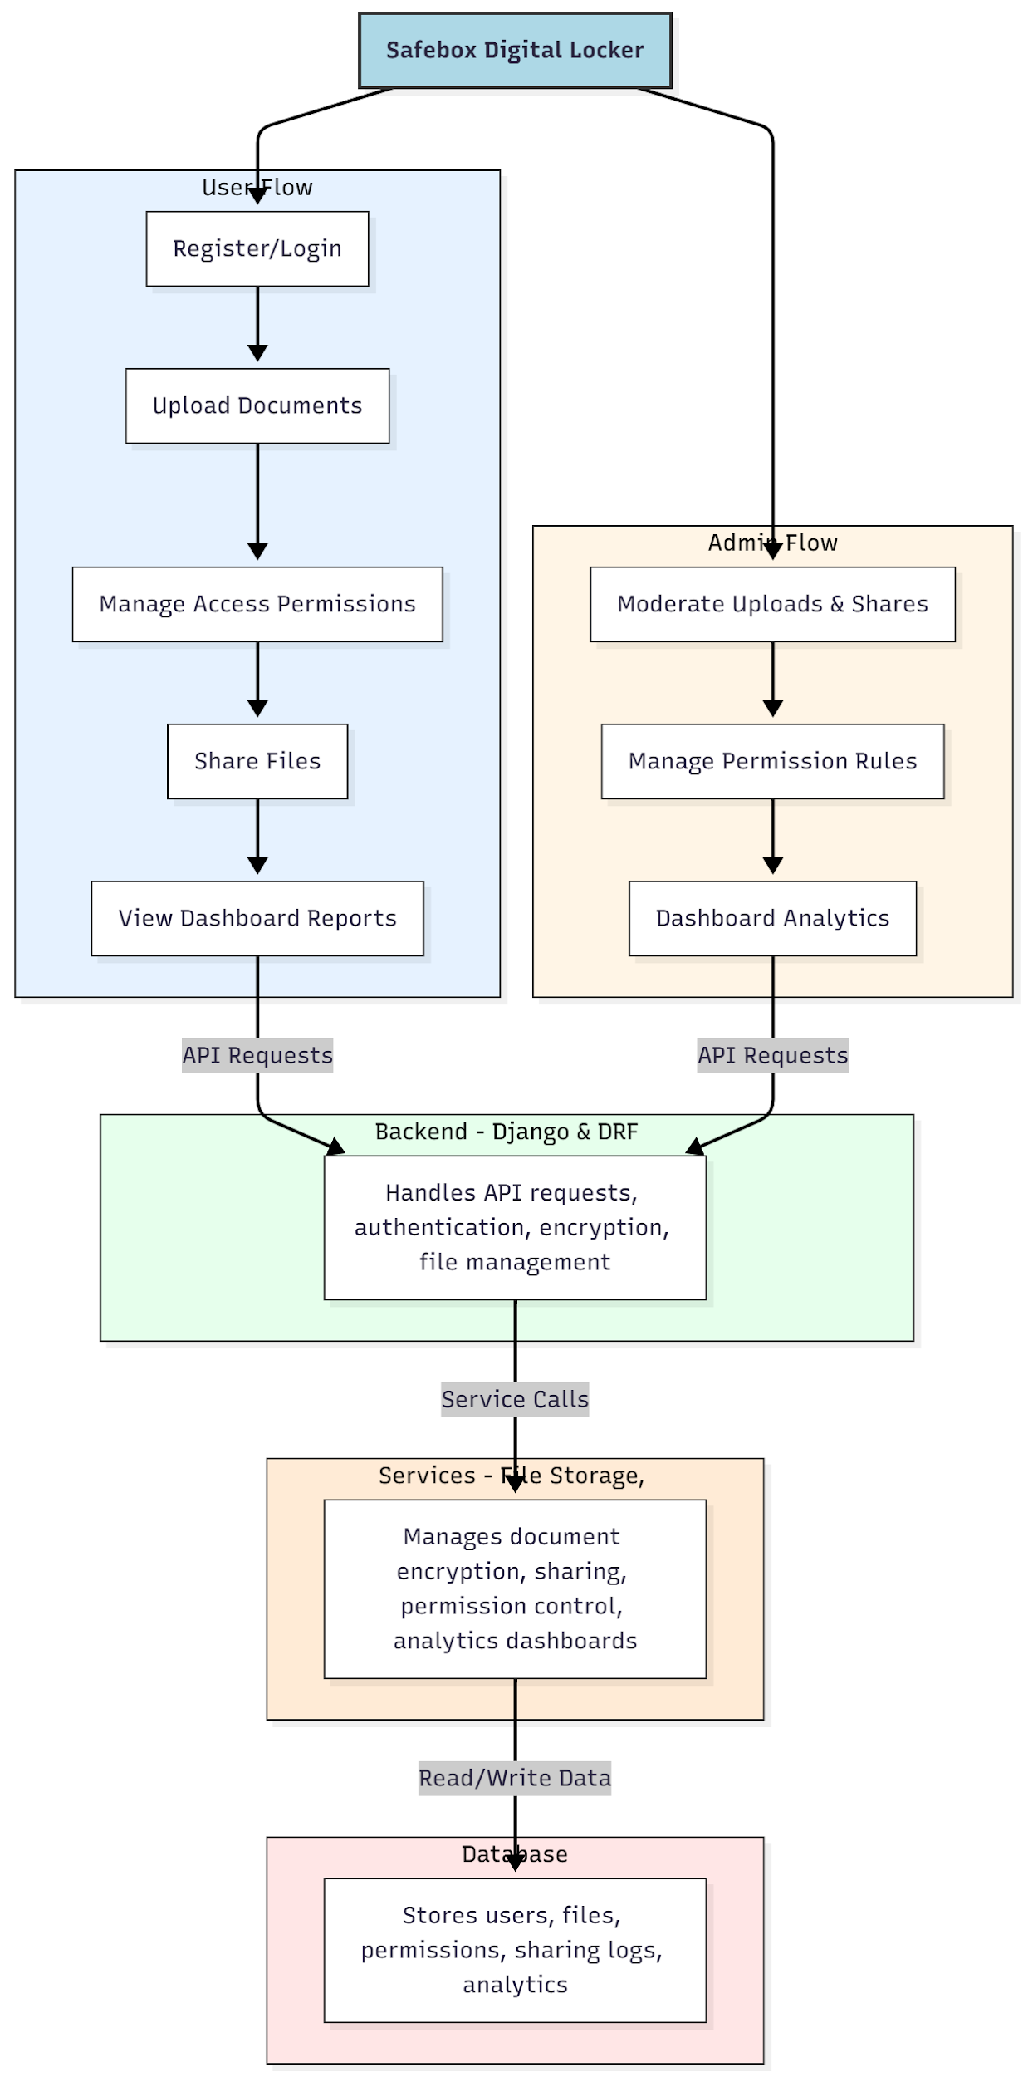

WORKING OF THE PROJECT:
Users register or log in, upload confidential documents, manage access permissions, share files with authorized recipients, and view dashboard analytics. The backend handles API requests, authentication, encryption, file management, and business logic. Services manage secure storage, sharing mechanisms, permission enforcement, and analytics dashboards. Administrators moderate uploads and shares, configure permission rules, and analyze dashboard data. The system ensures secure, trackable, and efficient management of digital files for personal and organizational use..

SOFTWARE REQUIREMENT:
- Backend:
  - Python 3.x
  - Django
  - Django REST Framework
  - SQLite/PostgreSQL
- Frontend:
  - Node.js and npm
  - React.js
  - Axios
- Development Tools:
  - Visual Studio Code
  - Postman (for testing APIs)
  - Git/GitHub (for version control)
- Server/Deployment (Optional):
  - Gunicorn, Nginx, or Heroku/AWS for hosting

ADVANTAGES OF THE PROJECT:

• Secure encrypted digital document storage
• Permission-based sharing for confidentiality
• Dashboard analytics for tracking file activity
• Administrative control over uploads and sharing
• Easy file upload and management
• Exportable and shareable documents
• Centralized management of sensitive files
• Reduces risks of data breaches and unauthorized access

APPLICATIONS OF THE PROJECT:
• Personal secure document storage
• Organizational confidential file management
• Permission-based document sharing systems
• Analytics dashboards for document usage
• File moderation and administrative oversight
• Educational institutions for student records
• Corporate HR and legal document management
• Safe cloud storage for sensitive information

REFERENCES:

- Django REST Framework Documentation — Django Software Foundation. Django Documentation. Available: https://docs.djangoproject.com/
- Django REST Framework. DRF Documentation. Available: https://www.django-rest-framework.org/
- React. React Official Documentation. Available: https://reactjs.org/docs/getting-started.html
- Redux. Redux Documentation. Available: https://redux.js.org/introduction/getting-started
- PostgreSQL Global Development Group. PostgreSQL Documentation. Available: https://www.postgresql.org/docs/
- MySQL. MySQL Reference Manual. Available: https://dev.mysql.com/doc/
- Git. Git Documentation. Available: https://git-scm.com/doc
- Node.js. Node.js Documentation. Available: https://nodejs.org/en/docs/
- Axios. Axios Documentation. Available: https://axios-http.com/docs/intro
- Socket.io Documentation – https://socket.io/docs/

